**package** com;

**import** java.io.File;

**class** Create {

**public** **static** **void** main(String[] args) {

File file = **new** File("JavaFile.java");

**try** {

**boolean** value = file.createNewFile();

**if** (value) {

System.***out***.println("Java File is created.");

}

**else** {

System.***out***.println(" file already exists.");

}

}

**catch**(Exception e) {

e.getStackTrace();

}

}

}

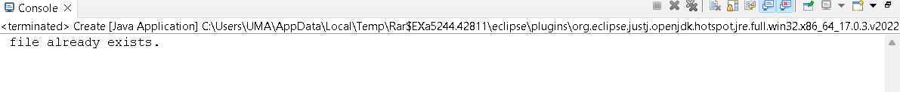

**package** com;

**import** java.io.File;

**import** java.io.FileNotFoundException;

**import** java.util.Scanner;

**public** **class** Read {

**public** **static** **void** main(String[] args) {

**try** {

File myObj = **new** File("filename.txt");

Scanner myReader = **new** Scanner(myObj);

**while** (myReader.hasNextLine()) {

String data = myReader.nextLine();

System.***out***.println(data);

}

myReader.close();

} **catch** (FileNotFoundException e) {

System.***out***.println(" error occurred.");

e.printStackTrace();

}

}

}



**package** com;

**import** java.io.FileWriter;

**public** **class** UpdateAfile{

**public** **static** **void** main(String args[]){

**try**{

FileWriter fwrite=**new** FileWriter("javafile.txt");

fwrite.write("Welcome to javaTpoint.");

fwrite.close();

}**catch**(Exception e){System.***out***.println(e);}

System.***out***.println("Successfull");

}

}



**package** com;

**import** java.io.*;

**public** **class** Delete {

**public** **static** **void** main(String[] args)

{

File file= **new** File("C:\\Users\\UMA\\Desktop\\mysoftware");

**if** (file.delete()) {

System.***out***.println("File deleted successfully");

}

**else** {

System.***out***.println(" the file deletion failed");

}

}

}

